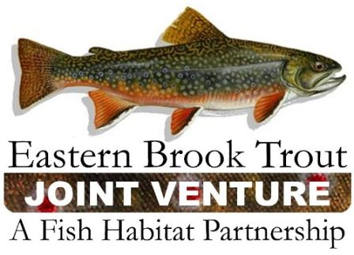

EBTJV Conservation Priorities, Common State-Level Objectives, and Habitat Objectives

EBTJV Conservation Priorities:

- Increase recreational fishing opportunities for wild brook trout;

- Protect the “best of the best” habitat that supports existing, healthy wild brook trout populations;

- Improve and reconnect adjacent habitats that have a high likelihood of supporting stable wild brook trout populations;

- Focus on critical wild brook trout spawning and early life history habitat in sub-watersheds classified as Intact;

- Preserve genetic diversity and strains of wild brook trout populations;

- Conserve unique wild brook trout life history strategies (i.e. lacustrine populations, large river populations, and coastal populations).

Common State-Level Objectives:

- Improve protection of brook trout resources.

- Maximize brook trout habitat and water quality protection through state and federal agencies.

- Pursue direct land purchase or conservation easements to protect brook trout habitat.

- Establish land conservation easements that require the use of Best Management Practices and include the development of stewardship plans.

- Assist landowners in utilizing existing land conservation programs.

- Minimize fish stocking impacts to wild brook trout populations.

- Mitigate factors that degrade water quality.

- Maintain or restore natural hydrologic regimes.
EBTJV Habitat Objectives

- Maintain the status, or no net less, of subwatersheds classified as Intact.

- Strengthen brook trout populations in subwatersheds classified as Intact.

- Establish self-sustaining brook trout populations in subwatersheds classified as Extirpated.

- Improve Reduced subwatersheds to Intact classification.

- Strengthen brook trout populations in subwatersheds classified as Reduced.

- Maintain Reduced subwatersheds in existing condition.

- Validate the predictive brook trout status model by assessing status in predicted subwatersheds.

- Maintain the status, or no net loss, of Intact pond and lake watersheds, and assess the status of unknown subwatersheds.

- Prevent the spread of invasive species into brook trout habitat.
  - Develop EBTJV-produced educational pamphlets that highlight state-level, regional, and range-wide threats from invasive species. Update annually.
  - Develop lists of invasives with state or federal agencies responsible for permitting aquaculture operators or distributors.
  - Eradicate invasive species from brook trout habitat where feasible.

- Expand and integrate state, federal, and private programs that support riparian conservation in watersheds that support brook trout populations.
  - Utilize CREP, WHIP, Partners for Fish and Wildlife, and state, county, or other conservation programs. This should include efforts to integrate alternative mitigation programs when applicable.

- Utilize state, federal and private programs that support watershed stewardship programs in systems containing brook trout.
  - Utilize USDA Healthy Forest Restoration Act through state forestry agencies.

- Partner with organizations on projects that involve nongame species, migratory birds, and brook trout.
  - Develop a list of organizations that peripherally could support work with brook trout restoration and protection. Such groups include, but are not limited to, the American Fisheries Society, Natural Heritage Program, Audubon Society, and Trout Unlimited.

